JUNAID GIRKAR

60004190057

TE COMPS A4

EXPERIMENT - 3

**AIM**: Implement Support Vector Machine.

**THEORY**:

**Support Vector Machine** (SVM) is a relatively simple Supervised Machine Learning Algorithm used for classification and/or regression. It is more preferred for classification but is sometimes very useful for regression as well. Basically, SVM finds a hyper-plane that creates a boundary between the types of data. In 2-dimensional space, this hyper-plane is nothing but a line.

In SVM, we plot each data item in the dataset in an N-dimensional space, where N is the number of features/attributes in the data. Next, find the optimal hyperplane to separate the data. So by this, you must have understood that inherently, SVM can only perform binary classification (i.e., choose between two classes). However, there are various techniques to use for multi-class problems.

**Support Vector Machine for Multi-CLass Problems**

To perform SVM on multi-class problems, we can create a binary classifier for each class of the data. The two results of each classifier will be :

* The data point belongs to that class OR
* The data point does not belong to that class.

For example, in a class of fruits, to perform multi-class classification, we can create a binary classifier for each fruit. For say, the ‘mango’ class, there will be a binary classifier to predict if it IS a mango OR it is NOT a mango. The classifier with the highest score is chosen as the output of the SVM.

**SVM for complex (Non Linearly Separable)**

SVM works very well without any modifications for linearly separable data. Linearly Separable Data is any data that can be plotted in a graph and can be separated into classes using a straight line.

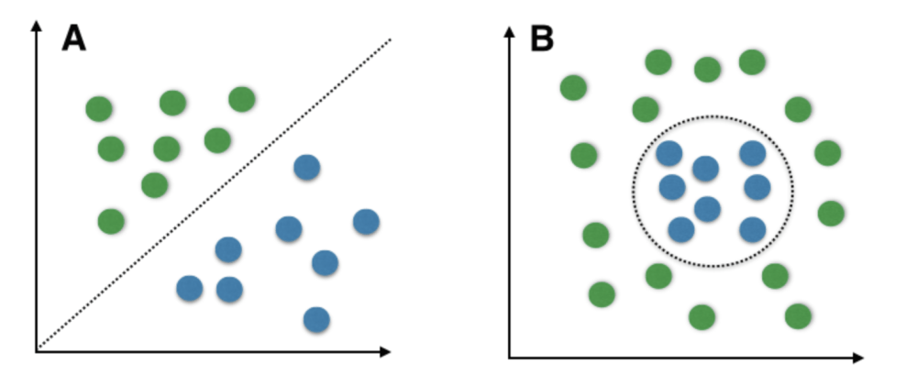

We use Kernelized SVM for non-linearly separable data. Say, we have some non-linearly separable data in one dimension. We can transform this data into two-dimensions and the data will become linearly separable in two dimensions. This is done by mapping each 1-D data point to a corresponding 2-D ordered pair.

So for any non-linearly separable data in any dimension, we can just map the data to a higher dimension and then make it linearly separable. This is a very powerful and general transformation.

A kernel is nothing but a measure of similarity between data points. The kernel function in a kernelized SVM tells you, given two data points in the original feature space, what the similarity is between the points in the newly transformed feature space.

**There are various kernel functions available, but two of are very popular :**

**Radial Basis Function Kernel (RBF):** The similarity between two points in the transformed feature space is an exponentially decaying function of the distance between the vectors and the original input space as shown below. RBF is the default kernel used in SVM.

| K(x,x') = exp(-\gamma||x-x'||²) |
| --- |

**Polynomial Kernel**: The Polynomial kernel takes an additional parameter, ‘degree’ that controls the model’s complexity and computational cost of the transformation

**Pros of Kernelized SVM:**

* They perform very well on a range of datasets.
* They are versatile : different kernel functions can be specified, or custom kernels can also be defined for specific datatypes.
* They work well for both high and low dimensional data.

**Cons of Kernelized SVM:**

* Efficiency (running time and memory usage) decreases as the size of training set increases.
* Needs careful normalisation of input data and parameter tuning.
* Does not provide a direct probability estimator.
* Difficult to interpret why a prediction was made.

**CODE:**

| # Support Vector Machine # Importing the libraries  import numpy as np import matplotlib.pyplot as plt import pandas as pd  # Importing the datasets  datasets = pd.read_csv('Social_Network_Ads.csv') X = datasets.iloc[:, [2,3]].values Y = datasets.iloc[:, 4].values  # Splitting the dataset into the Training set and Test set  from sklearn.model_selection import train_test_split X_Train, X_Test, Y_Train, Y_Test = train_test_split(X, Y, test_size = 0.25, random_state = 0)  # Feature Scaling  from sklearn.preprocessing import StandardScaler sc_X = StandardScaler() X_Train = sc_X.fit_transform(X_Train) X_Test = sc_X.transform(X_Test)  # Fitting the classifier into the Training set  from sklearn.svm import SVC classifier = SVC(kernel = 'linear', random_state = 0) classifier.fit(X_Train, Y_Train)  # Predicting the test set results  Y_Pred = classifier.predict(X_Test)  # Making the Confusion Matrix   from sklearn.metrics import confusion_matrix cm = confusion_matrix(Y_Test, Y_Pred)  # Visualising the Training set results  from matplotlib.colors import ListedColormap X_Set, Y_Set = X_Train, Y_Train X1, X2 = np.meshgrid(np.arange(start = X_Set[:, 0].min() - 1, stop = X_Set[:, 0].max() + 1, step = 0.01),  np.arange(start = X_Set[:, 1].min() - 1, stop = X_Set[:, 1].max() + 1, step = 0.01)) plt.contourf(X1, X2, classifier.predict(np.array([X1.ravel(), X2.ravel()]).T).reshape(X1.shape),  alpha = 0.75, cmap = ListedColormap(('red', 'green'))) plt.xlim(X1.min(), X1.max()) plt.ylim(X2.min(), X2.max()) for i, j in enumerate(np.unique(Y_Set)):  plt.scatter(X_Set[Y_Set == j, 0], X_Set[Y_Set == j, 1],  c = ListedColormap(('red', 'green'))(i), label = j) plt.title('Support Vector Machine (Training set)') plt.xlabel('Age') plt.ylabel('Estimated Salary') plt.legend() plt.show()  # Visualising the Test set results  from matplotlib.colors import ListedColormap X_Set, Y_Set = X_Test, Y_Test X1, X2 = np.meshgrid(np.arange(start = X_Set[:, 0].min() - 1, stop = X_Set[:, 0].max() + 1, step = 0.01),  np.arange(start = X_Set[:, 1].min() - 1, stop = X_Set[:, 1].max() + 1, step = 0.01)) plt.contourf(X1, X2, classifier.predict(np.array([X1.ravel(), X2.ravel()]).T).reshape(X1.shape),  alpha = 0.75, cmap = ListedColormap(('red', 'green'))) plt.xlim(X1.min(), X1.max()) plt.ylim(X2.min(), X2.max()) for i, j in enumerate(np.unique(Y_Set)):  plt.scatter(X_Set[Y_Set == j, 0], X_Set[Y_Set == j, 1],  c = ListedColormap(('red', 'green'))(i), label = j) plt.title('Support Vector Machine (Test set)') plt.xlabel('Age') plt.ylabel('Estimated Salary') plt.legend() plt.show() |
| --- |

**OUTPUT:**

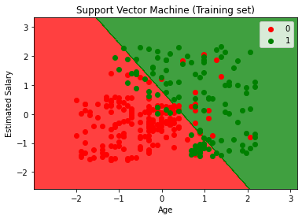

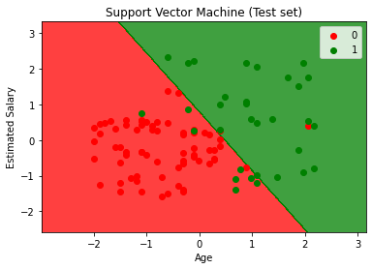

| Confusion Matrix: [[66 2]  [ 8 24]] |
| --- |

**CONCLUSION**: We learnt about Support Vector Machine which is one of the supervised machine learning algorithms and implemented it in python.